1.
Prove by mathematical induction.

2.
(i) 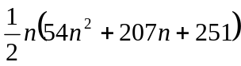 , 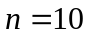
(ii) 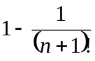

3.
(i) 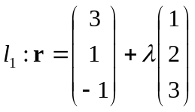
(ii) 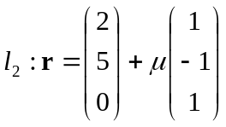
(iii) The point of intersection is 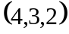
(iv) 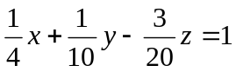

4.
(i) 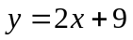 , 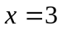
(ii) local maximum point : 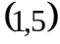 , local minimum point : 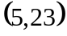

5.
, 

